**Himachal Pradesh**

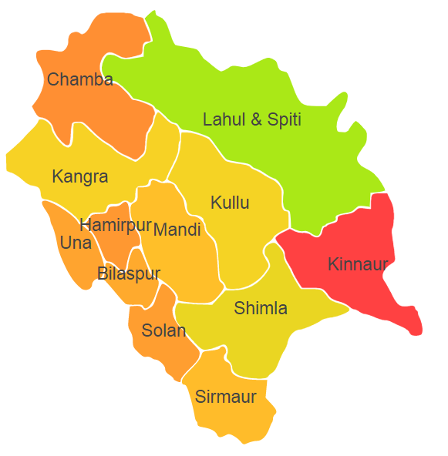

Himachal Pradesh comprises of Agro Ecological Region (AER) 14.

**Agro-Eco Region 14:** AER 14 in Himachal Pradesh comprises of Bilaspur, Chamba, Hamirpur , Kangra, Kinnaur, Kullu , Lahul & Spiti, Mandi, Shimla, Sirmaur, Solan and Una districts of Western Himalayas under Agro Ecological Sub Regions (AESR) 14.1,14.2 and 14.3.